# Experiment No.6 Date:09/11/2021

House Wiring Circuits in TinkerCAD

**Objectives:**

1. To make a simple wiring circuit for two lamps
2. To make a staircase wiring/corridor wiring/godown wiring

**Circuit**

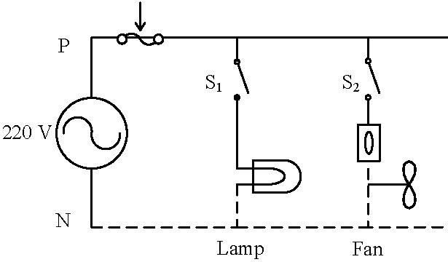

**Wiring Circuit for a Lamp, Fan and Socket**

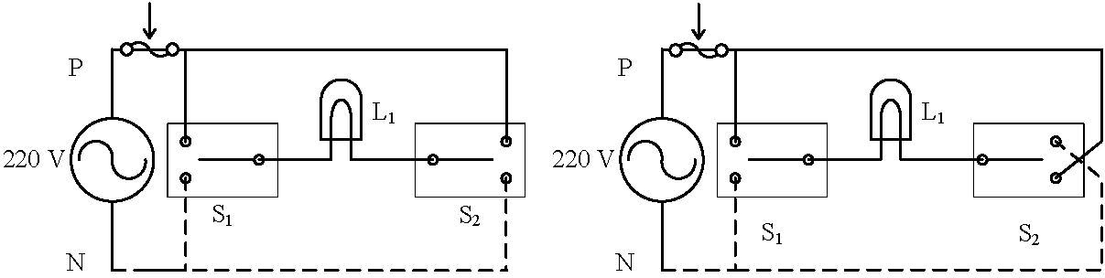

**Stair Case Wiring Circuit**

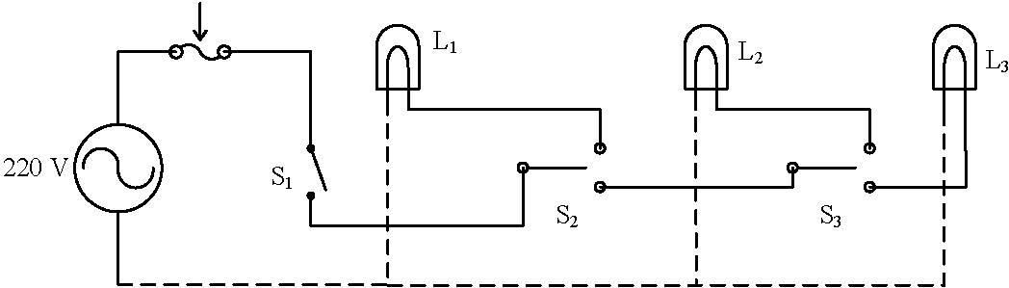

**Corridor/Godown Wiring Circuit**

**Observation:**

|  |  |  |
| --- | --- | --- |
| **S. No** | **Parameter to be measured** | **Value Measured/ Calculated** |
| 1 | Voltage Across L1 | 12V |
| 2 | Current drawn by L1 | 250 mA |
| 3 | Power Absorbed by L1 | 3W |
| 4 | Equivalent Resistance of L1 | 48Ω |

**Staircase Wiring Observation:**

|  |  |  |
| --- | --- | --- |
| **Switch 1** | **Switch 2** | **Lamp1**  **(XOR LOGIC)** |
| **OFF** | **OFF** | **OFF** |
| **ON** | **OFF** | **ON** |
| **OFF** | **ON** | **ON** |
| **ON** | **ON** | **OFF** |

**Double Port Single Throw (DPST) Switch:**

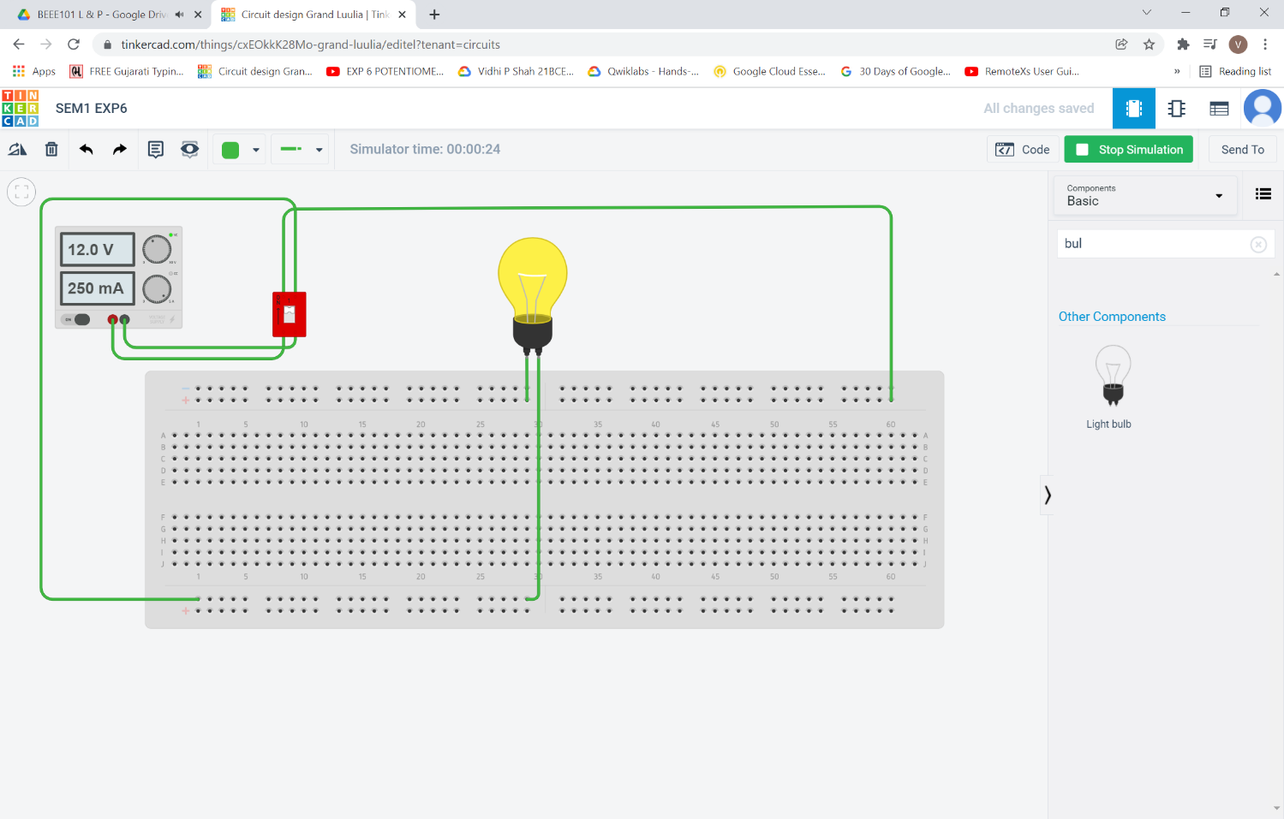

**Calculation:**

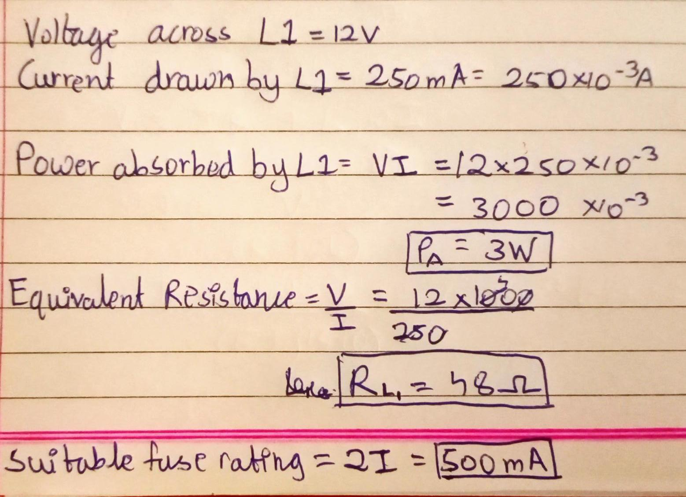

**Staircase Wiring:**

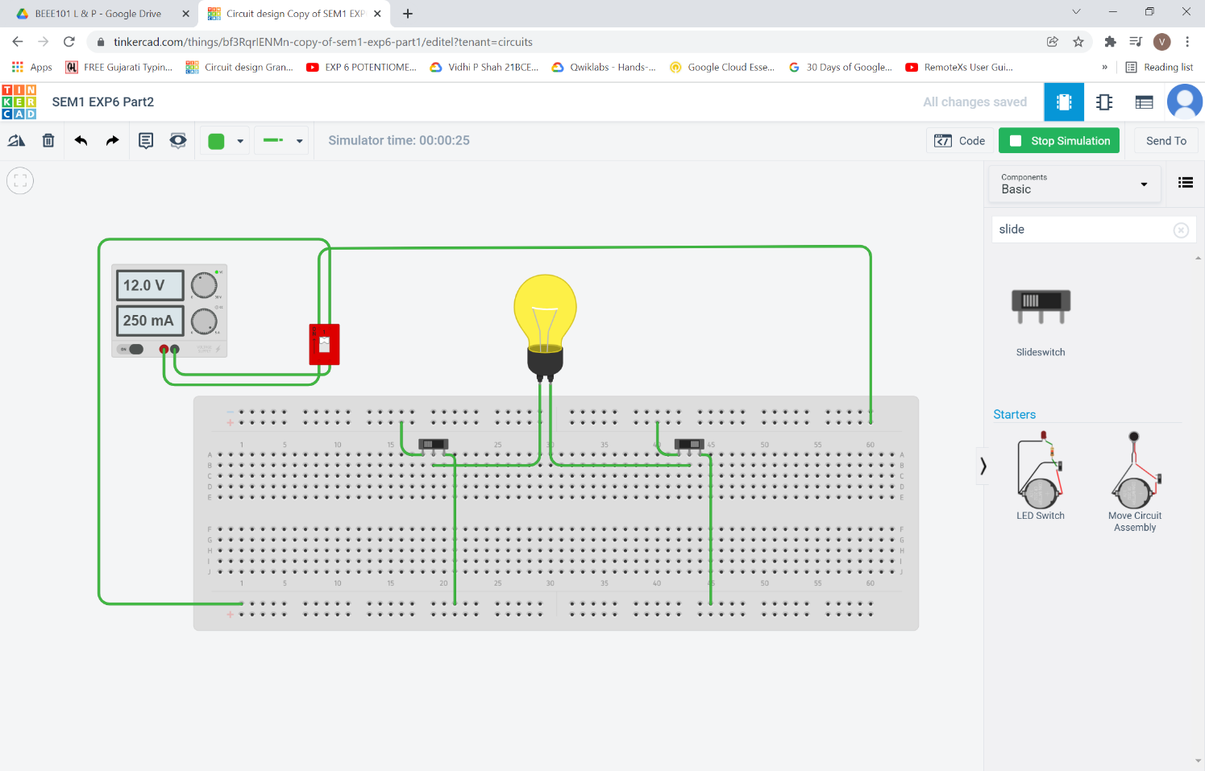

**Godown Wiring:**

